# MCTV Report

### Advantages and challenges of moving MCTV Limited to the cloud

## Advantages:

## **Cost Effectiveness:**

An extremely flexible pricing structure is one of the top benefits of the cloud. Most cloud providers give businesses the flexibility to pay by the month which could save MCTV ltd money rather than continuously using up ink and paper.

Cloud seems to help large companies, As MCTV is a small retail company, they can control their costs by only paying for the cloud services they chose to use. MCTV can run their web applications without committing to a fixed cost for servers, software, setup or maintenance.

## **Quick and Easy Set Up:**

Businesses can set up their cloud within a matter of few hours. It can be easily bought on the Internet and deployed and configured remotely through the cloud provider website.

MCTV’s IT team can very easily configure and manage the set up remotely with just an internet connection and a device.

## **Little to no maintenance required:**

The cloud provider is responsible for the maintenance of the hardware, software, and networks in the cloud. MCTV, therefore, do not need to worry about keeping their infrastructure up-to-date or worry about aspects like security and upgrades. This is a big advantage as it allows MCTV to run the infrastructure with minimal IT staff, thereby significantly reducing the overall costs for staff and allows the company to have extra cash to invest in other things.

## Challenges:

## Security Issues:

MCTV ltd data might be at risk. Cloud computing means [internet computing](https://www.thebalancesmb.com/definition-of-mobile-computing-2533640). So it could be slightly risky for MCTV to be using cloud computing applications that involve using or storing data that they are not comfortable having on the internet.

The fact that MCTV’s cloud data is accessible from anywhere on the internet may seem like a big advantage. However, this means that [if a data breach](https://www.thebalance.com/how-a-data-breach-could-affect-your-credit-960777) occurs via hacking, a disgruntled employee, or careless username/password security, MCTV’s company data can be compromised.

Downtime:

This may be one of the worst disadvantages of cloud computing. No cloud provider, even the very best, would claim immunity to service outages. Cloud computing systems are internet based, which means MCTV’s access is fully dependent on their internet connection.

## **Limited control and flexibility:**

To varying degrees (depending on the particular service) MCTV ltd may have limited control over the function and execution of the cloud services which they require. Cloud provider management policies might impose limits on what customers can do with their deployments.

MCTV are also limited to the control and management of their applications, data, and services, but not the backend infrastructure. Of course, none of this will normally be a problem, but it should be taken into account by MCTV ltd.

### The costs and benefits of your solution

Benefits:

Marketing:

Dynamics CRM marketing module gives MCTV the ability to efficiently manage contacts, leads, and campaigns including prospect and customer segmentation, as well as campaign planning and execution. It even provides analytics, comprehensive reporting and seamless collaboration between sales and marketing.

On-Premise & Cloud Deployment:

Dynamics CRM allows MCTV to choose from various deployment options like on-premises, cloud or partner-hosted deployment. MCTV can choose the best model depending on its company’s requirements. Any member of staff can access Dynamics CRM either via Microsoft Outlook, a web browser, or an internet-enabled mobile phone.

## Efficient

Because Microsoft Dynamics CRM keeps all information in one place, there are no more large piles of information. In addition to this everyone has access to all the information they need and they work together more effectively.

Costs:

## **Possible downtime**

Like all cloud systems, Dynamics CRM Online has experienced down time and performance issues. Granted, this is very likely to happen with a system on premise too, but users feel more helpless when it is out of their control to repair the software.

## **Data Storage Limits**

Microsoft Dynamics CRM Online includes 5 gigabytes of data storage. MCTV can buy additional storage space for 9.99 per gigabyte per month. 5 gigabytes may sound like a lot until you realize this is for the entire organization, not per user. This can end up being very costly for MCTV.

### 3 other alternative packages that you have investigated in your area that are direct competitors.

## Salesforce

One of the long-standing rivalries in business IT is Microsoft Dynamics CRM vs. Salesforce, two leading customer relationship management (CRM) vendors whose solutions are strikingly [hard to differentiate](https://technologyadvice.com/crm/blog/compare-crm-software-like-an-expert/). However, Microsoft Dynamics has been around longer and works out cheaper.

## Agile CRM

While MS Dynamics CRM may serve well for huge enterprises, Agile CRM is its best alternative for small and medium sized businesses. With a remarkable sales and marketing feature set that includes marketing automation, web engagement, real-time analytics and advanced reporting, Agile lets small and medium sized businesses similar to MCTV sell and market at a fraction of the cost of Microsoft Dynamics.

## Sugar CRM

This is designed for the organizations ranging from the small companies to corporations needing enterprise level support. Even though the platform includes the basic features found in the MS dynamics CRM systems, Sugar CRM also stands out for call centre automation, sales forecasting and contextual intelligence from internal and external sources. The solution integrates with over 124 popular applications such as Zapier, Xero and Zendesk etc.

- - - - - - - - - - - - - - - - - - - - - - - - - - - - - - - - - - - - - - - - - - - - - - - - - - - - - -- - - - -- - - - -- - - - - - - - - - - - - - - - - - - - - - - - - - - - - - - - - - - - - - - - - - - - - - - - -- - - - - - - - - - - - - - - - - - - - - -- - - -- - - - - - - - - - - - - - - - -- - - - - - - - - - -- - - -- - - - - - - - -- - - - - - -- - -- --

### Training will be important so that each individual will need to be trained on the chosen software. Neither of the team members are very technology literate.

Microsoft Dynamics 365 is designed to support the sales process from acquiring a new lead through the close of a sale.

CRM has a place to store the contact information for new leads, a place to track the follow-up communications such as Phone Calls, Emails, and Appointments. And the ability to qualify a Lead into an Account, Contact, and Opportunity.

CRM keeps Leads in a separate area in order to ensure that the main database of Accounts and Contacts does not get cluttered with people MCTV doesn’t know.

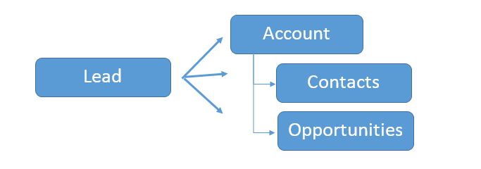

As part of the Opportunity, you may create a Quote in CRM and convert that to an Order and an invoice.  CRM’s Product Catalog provides the basis for this process.  Organizations using this functionality often have an integration with their financial software or Enterprise Resource Planning (ERP) software.  In this way the product catalogue and pricing has a single source, is kept up-to-date, and the complexities of ordering and invoicing are handled appropriately.

Below represents a typical integration between CRM and ERP.

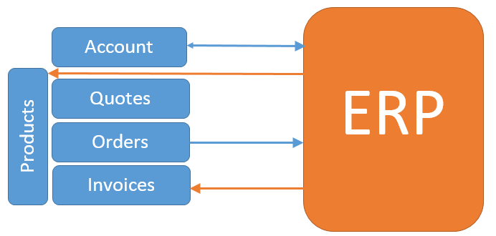

The end of a typical sales process is the close of the Opportunity as Won or lost.  If the opportunity is Won, the Relationship Type on the Account is often changed from Prospect to Customer

#### Configuring Your Microsoft Dynamics 365 Sales Process:

Every organization that implements CRM for sales must spend a little time analyzing their unique processes and configuring CRM to reflect that.

This might mean just changing a few fields or it might mean significantly modifying the forms and view, deciding to add new record types, and/or deciding to disable unused features.

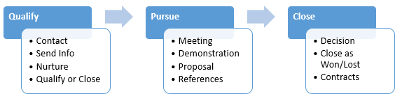

Should You Use Leads?

Most people think of leads as new hot opportunities that need immediate follow-up.

In fact, most CRM systems don’t have a Leads area, they have a single database of contacts and companies.

Every hot lead is entered in and as they cool down, they grow old and mixed in with the thousands of contacts gathered over the years.

### Finally, you need to make the case for why we should choose your project ahead of your other family members.

1. Enhanced customization
2. Dynamics 365 works the way the organization works with enhanced system customization.
3. **It can be tailored to function the way MCTV already works or wants to work**. Microsoft Dynamics CRM client views, forms, and links can be customized and configured without additional development.
4. Seamless application and data source integration
5. Microsoft Dynamics 365 holds the power of Microsoft NET Framework and Web services.
6. It enables companies to integrate isolated, legacy business solutions and applications.
7. Dynamics 365 connects with your third-party applications to help break down information.
8. It has clear adaptability.
9. It is totally planned to suit a little organization such as MCTV ltd.